instruCTIONS FOR DRAFTING A PAPER
FOR THE “41st IAHS World Congress: Sustainability and InNovation for the future’

First Author¹*, Second Author¹ and Third Author²
1: Group or Department
University/Institution A
Postal address
e-mail: {FirstAuthor, SecondAuthor}@universityA.pt, web: http://www.group.pt
2: Group/Department
University/Institution B
Postal address
e-mail: ThirdAuthor@universityB.pt, web: http://www.group.pt
Keywords: Paper, Instructions, IAHS, Sustainability, Algarve
Abstract This document gives you all the information and instructions you need to draft your paper for inclusion in the Proceedings of the 41st International Association for Housing Science (IAHS) World Congress, which is taking place in Albufeira, Algarve, Portugal from 13-16th September 2016. Papers must be written in English, using MS-Word. The first page must contain: the title of the paper, authors’ names and institutions, keywords and abstract. This page will be used for the book of abstracts and must on no account exceed one page. All papers must be submitted electronically using the Congress Paper Submission System. Detailed instructions are provided on the congress website: http://www.iahs2016.uc.pt/.

- INTRODUCTION
The Proceedings, including text and figures, will be published electronically in Portable Document Format (.pdf). Abstracts must be submitted electronically using our web-based abstract submission system at http://www.webchairing.com/iahs2016/submission/ before the Abstract Submission Deadline is reached. The formatting style given in this template must be followed strictly on all submitted files. After acceptance, the final version of the paper must be submitted electronically at http://www.webchairing.com/iahs2016/intra/ before the Final Paper Submission Deadline is reached. The final version will not be sent for further refereeing, but should take duly into account the reports received from the referees. The organisers will not commit to including any paper in the Proceedings that is received after the stipulated deadline. At least one author must be registered and have paid the requisite fee by the final paper submission deadline for the paper to be included in the Congress Scientific Programme. One person may co-author several papers as long as each paper is presented by a different co-author. Note that each valid registration allows for the submission of one, and only one, paper to the conference.
- GENERAL SPECIFICATIONS
The paper must be written in English and must strictly follow the formatting style given in this template. Authors should carefully check their manuscripts for correct grammar and spelling. The print area must be centred on each page and should cover an area of 16 x 22.2 cm. The paper and its figures, tables and references must be 4 to 10 pages long. Papers must be converted into Portable Document Format (pdf) prior to sending. The file may not exceed 4 Mb.
- TITLE, AUTHORS, INSTITUTION, KEYWORDS
The first page must contain the title, author(s) and relevant institution(s), keywords and abstract. The first page will be used for the book of abstracts (the abstract must not, in any circumstances, extend beyond the space available on the first page). The introduction must start on the second page and follow the formatting style of this file.
  - Paper title
The title must be in Times New Roman, 14 pt font, bold, upper case and centred. If the title occupies more than one line, the line spacing should be single.
  - Authors
Authors’ first name and surname must be given in full (not initials), as in the beginning of this document. The names must be in Times New Roman, 12 pt font, bold, and 12 pt below the title. A header with the authors’ names must be included. If the authors’ names occupy more than one line, the line spacing should be single.
  - Institution
Details of the authors’ institution(s) must be in Times New Roman, 11 (10.95) pt, 12 pt below the list of authors. The line spacing between the institutions should be 12 pt. Authors which belong to the same institution must be grouped, as shown for the first and second author at the beginning of this template. Do not repeat unnecessary information.
  - Keywords
No more than six keywords are allowed. They should be aligned left and in Times New Roman 12 pt. The first line must start with the word Keywords, in bold. The line spacing between the institutions and keywords should be 12 pt. If the Keywords occupy more than one line, the line spacing should be single.
  - Abstract (in the body of the paper)
The body of the paper must contain an abstract thereof, written in Times New Roman, 12 pt, italics. The word ‘Abstract’ must be in bold and not in italics at the start of the first line. The Abstract text must be justified, in italics and have a 12 pt space between it and the keywords, as shown on the first page of these instructions. The line spacing should be single. The vertical spacing between paragraphs should be 6 pt.
The abstract must not, in any circumstances, extend beyond the space available on the first page. This first page, with the paper’s title, its authors’ names and institutions, keywords and abstract, will be used for the book of abstracts.
- HEADINGS
  - Main headings
The main headings must be aligned left, Times New Roman 12 pt font, bold, upper case. Line spacing must be 12 pt before and 6 pt after each main heading.
  - Subheadings
The subheadings must be aligned left, Times New Roman 12 pt font, bold, initial capital for fist word. Line spacing must be 12 pt before and 6 pt after each subheading.
- HEADERS
As shown in these instructions, the first page has one header and the header of the remaining pages consists of the authors’ names (please include them, formatted according to these instructions). Note that the headers are outside the print area (see Figure 1).
- TEXT
The main body text shall be Times New Roman, 12 pt, single spaced, justified and in a single column. The vertical spacing between paragraphs should be 6 pt.
- PAGE NUMBERING
Papers will be locatable by author’s name, title or topic. Pages should be numbered in Times New Roman, 12 pt, centred and at the foot of the page, outside the print area.
- FIGURES
All figures must be numbered consecutively and identified by their caption. Figure captions must be Times New Roman, 10 pt using both upper and lower case, and centred.
There must be a 6 pt space between each figure and its caption, and a 12 pt space between the body text and the upper border of the figure and the last line of the caption and the next section of the text.
Figures may be within the body of the text or at the end of the paper.
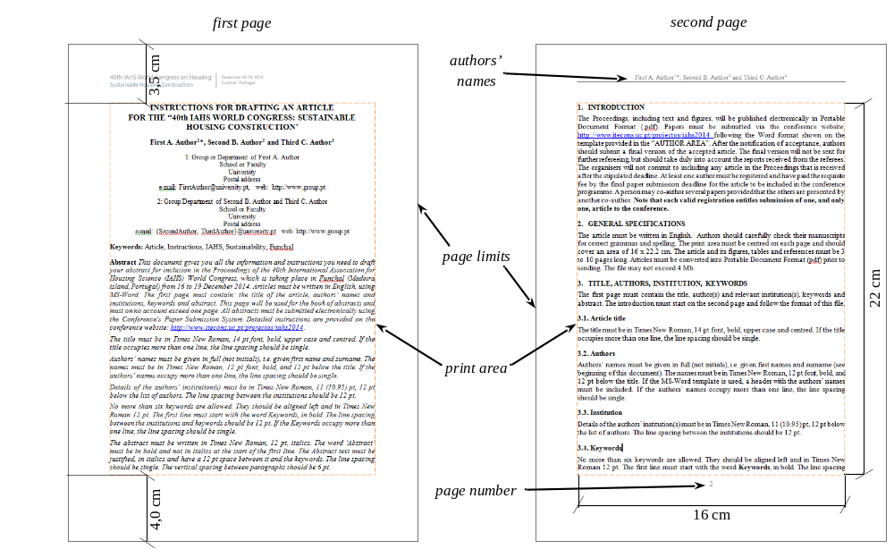
Figure 1. Layout of first page and subsequent pages.
- EQUATIONS
Equations must be numbered in Arabic numerals, enclosed in brackets. Equations must be centred and separated from the text above and below by a 6 pt space.
The example below is a single-line equation:
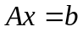 (1)
The example below is a group of aligned equations:
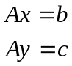 (2)
- TABLES
All tables must be numbered consecutively and identified by their caption. A 12 pt space must exist between the last line of the text and first line of the caption. Table captions must be Times New Roman, 10 pt using both upper and lower case, and centred. There must be a 6 pt space between each table and its caption and the lower border of the table and the next section of the text.
Table 1. Example of table layout
C11 | C12 | C13
C21 | C22 | C23
C31 | C32 | C33
C41 | C42 | C43
C51 | C52 | C53
- REFERENCES
References within the text must be cited using numbers enclosed by square brackets, according the next example. At the end of the text references must be in numerical order, as shown at the end of these instructions. The references should following the IEEE (Institute of Electrical and Electronics Engineers) style.
Example:
- "...end of the line for my research [5].";
- "Several recent studies [6, 7, 8] have suggested that...".
References section presents an example for a book [1], journal paper [2] and conference paper [3] citations.
- CONCLUSIONS
The paper must have a section containing some final considerations and the main conclusions drawn from the work described that will be presented at the conference.
It is noted that:
- Papers must be written in accordance with the format of the template file available in the “AUTHOR AREA” section of the congress website: http://www.iahs2016.uc.pt/;
- Papers must be converted into Portable Document Format (pdf) prior to submission and this file may not exceed 4 Mb;
- The paper and its figures, tables and references must be 4 to 10 pages long;
- Abstracts must be submitted electronically using our web-based abstract submission system at http://www.webchairing.com/iahs2016/submission/;
- After acceptance, the final version of the papers must be submitted electronically at http://www.webchairing.com/iahs2016/intra/;
- Papers must be sent by the stipulated deadlines in the “IMPORTANT DATES” section of the congress website;
- The organisers will not commit to include in the Proceedings any paper that is received after the stipulated deadlines;
- For each paper, at least one author must have registered in the “REGISTRATION” section of the congress website and MUST have paid the registration fee by the final paper submission deadline for the paper to be included in the conference programme;
- Only one paper presentation per registration is allowed.

References
- L. Godinho, A. Tadeu and P. Amado Mendes P. “Performance of the MFS in the computation of seismic motion and rotation” in The Method of Fundamental Solutions - A Meshless Method, Eds. C. S. Chen, A. Karageorghis e Y.S. Smyrlis, Dynamics Publishers: Atlanta, pp. 281-298, 2008.
- R. Caponeto and G. De Francisci, “Ecological Materials and Technologies in Low Cost Building Systems – New Techniques for Clay Applied to the Types of Buildings for Housing”. International Journal for Housing Science and Its Applications, vol. 37, n.º4, pp. 229–238, 2013.
- A. Dexter, L. Chiesa, C. Xie, “Using Infrared Thermography to Visualize the Invisible: Investigating Heat Transfer”, in Proceedings of 11th International Conference on Quantitative InfraRed Thermography: Naples, Italy, June 11-14, 2012.

